**ACCESS TIMES WITH AND WITHOUT LOAD BALANCER**

JMeter Tests without LB:

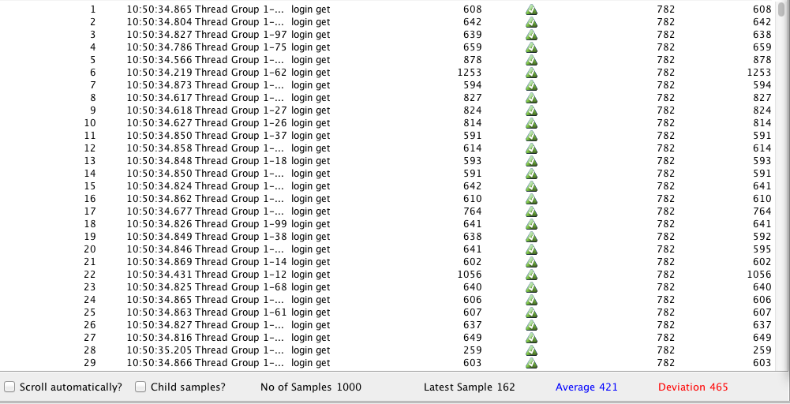

This screenshot shows a jMeter test for our application, for a load of 1000 users, when accessed without a load balancer.

The average response time is 421, which should be reduced to 300 ideally.

We hope that this time will improve when we introduce a load balancer, which alternates requests between two tomcat server.

JMeter Tests with LB:

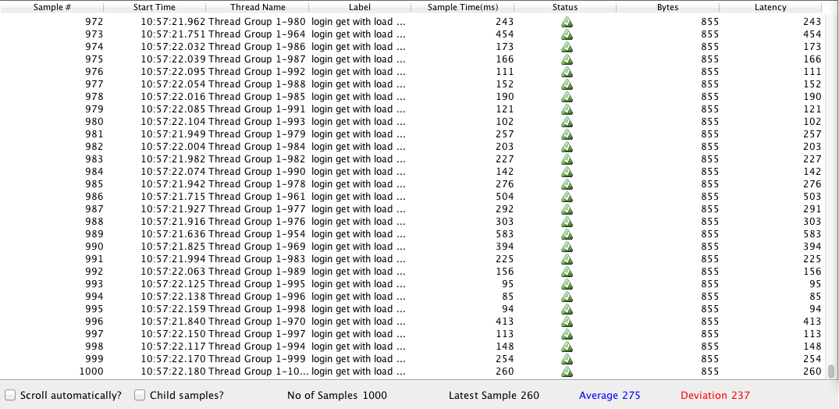

After we introduce a load balancer, the average time has reduced to 275. Please not that the response time reduced to approximately half when a tomcat cluster of size 2 was used. If we add more worker nodes, this time will reduce further.

Thank you!